Item Name: Tiny SP RACING F3_EVO_BRUSH flight controller for indoor-FPV
Dimension: 23mm*19.5mm*5mm
Thickness: 1.2mm
Weight: 2g
Features:
1. Tiny F3_EVO_Brush revision is out of the F3 EVO SP RACING is based on a SP RACING F3 EVO firmware 32 brush flight control.
2.The flight control support 1S (4.2V)
3. Independent design of the circuit structure, comes with the Voltage control technology, 1S lipo battery input, the UART1/2/3 output 5V, DSM port output 3.3V
4.Using STM32F303CCT6 + MPU6500, advanced hardware platform F3 guarantee more stable flight
5. With a large current NMOS transistors, operating current of up to 10A or more. Each Brushed motor is equipped with freewheeling diodes.
6.Support for PPM, SBUS, DSM/DSM2/DSMX receiver input signal.
7.In support of the world almost all hollow cup motor, including 1020 coreless motor.
Connection diagram:
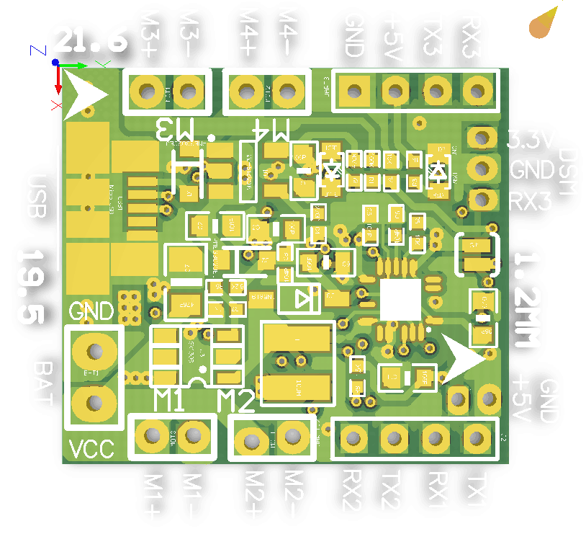

Micro USB socket: Connect to computer to flash firmware and configure the flight controller
M1/M2/M3/M4:Connect to Brush motor
VCC/GND: Connect to the battery 1S Lipo support
UART1: GND +5V RX1 TX1 , Could connect to OSD
UART2: GND +5V RX2 PPM/SBUS Receiver input（RX2）
UART3: GND +5V RX3 TX3 Could connect to GPS OR Telemetry module ,could not use when DSM/DSM/DSMX Receiver Used
DSM/DSM2/DSMX: 3.3V GND RX3 DSM/DSM2/DSMX Receiver input

Receiver configuration:
1. DSM receiver soldered directly to the DSM/DSM2/DSMX Receive interface 3.3V, GND, RX3. Enable Seria_RX for UART3 and Set Receiver mode RX_SERIAL ,Select Spektrum1024(DSM/DSM2) or Spektrum2048(DSMX) in Cleanflight configurator.
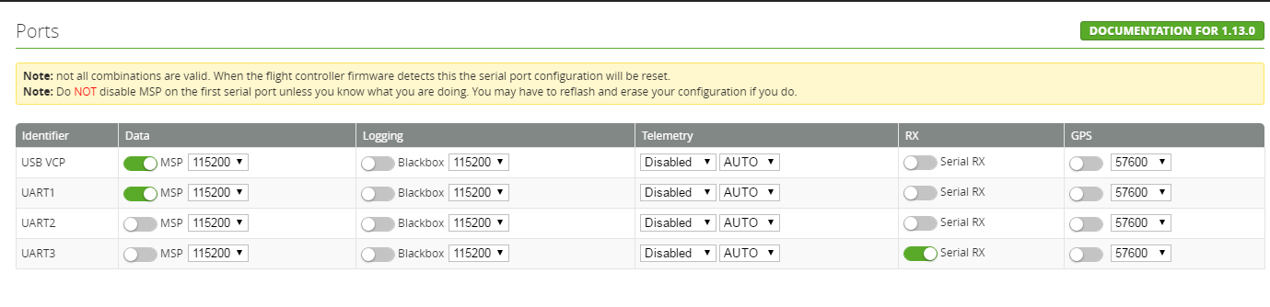
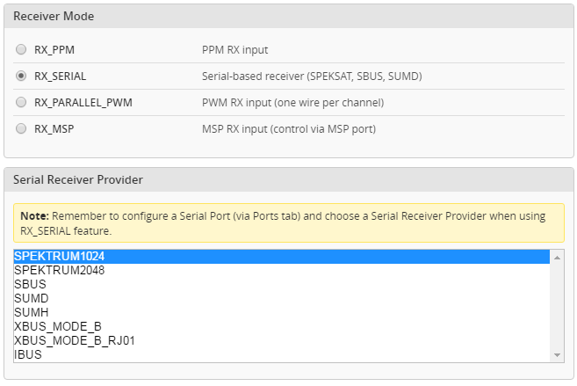
2. SBUS receiver welded to the UART2 GND, + 5V, RX2 . Then Enable Seria_RX and Set Receiver mode RX_SERIAL ,Select Sbus signal in Cleanflight configurator.
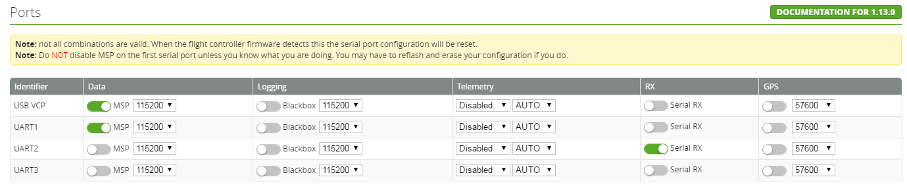
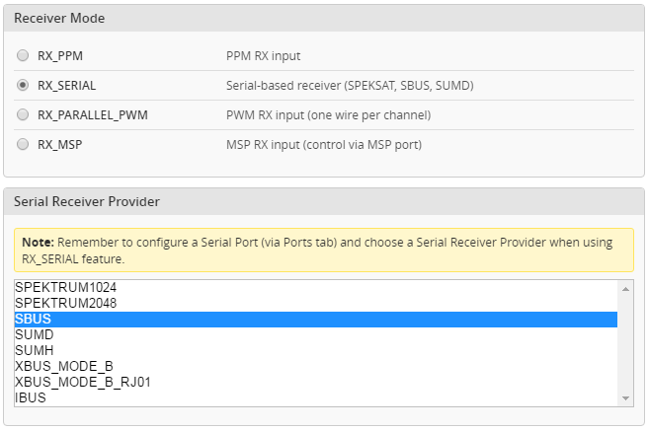
3. PPM receiver welded to the UART2 GND, + 5V, RX2 .Then set Receiver mode to RX_PPM in Cleanflight configurator.
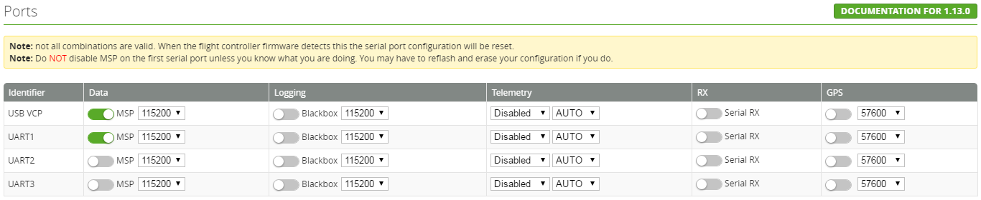
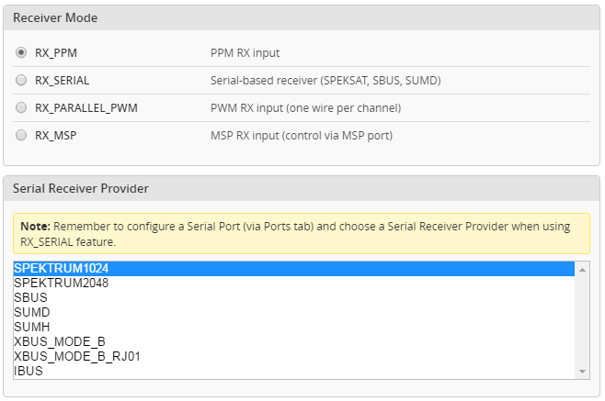

FIRMWARE FLASH -Tiny F3 EVO_Brush

The following tutorial covers flashing Cleanflight Firmware onto the Tiny F3 EVO_Brush Flight Controller. Betaflight is the same steps like Cleanflight.

Installing the ST drivers:
(For Windows Only)
Download and install the DfuSe demo package.
Open an explorer window and browse to (assuming you’ve installed to the default path) C:\Program Files (x86)\STMicroelectronics\Software\DfuSe v3.0.5\Bin\Driver
Browse two folders deeper to the folder relative to your Operating System version, and x86-32bit or x64-64bit variant.
Click the dpinst_x##.exe to install the driver.
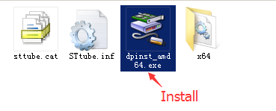

Installing Cleanflight Configurator:
(For Windows Only)
You must use Cleanflight Configurator v 1.0.0 or newer.
The following assumes you also have the Chrome Browser installed.
Get the latest Cleanflight Configurator (+ Add to Chrome)

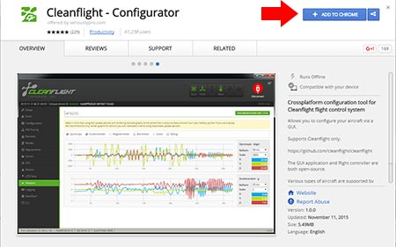

Replacing the ST Driver with WinUSB driver:
(For Windows Only)
- Plug your Tiny F3 EVO_Brush board onto your computer. Open cleanflight configurator , you should see the serial com port
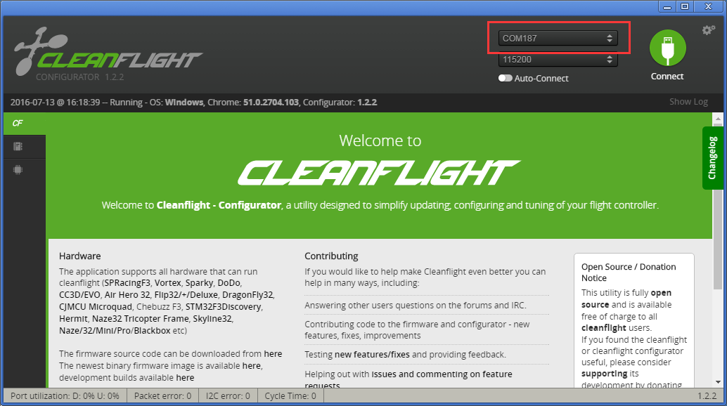

- Click “Firmware Flash” menu, select the latest firmware for Tiny F3 EVO_Brush and load firmware [online] or load firmware [Local]
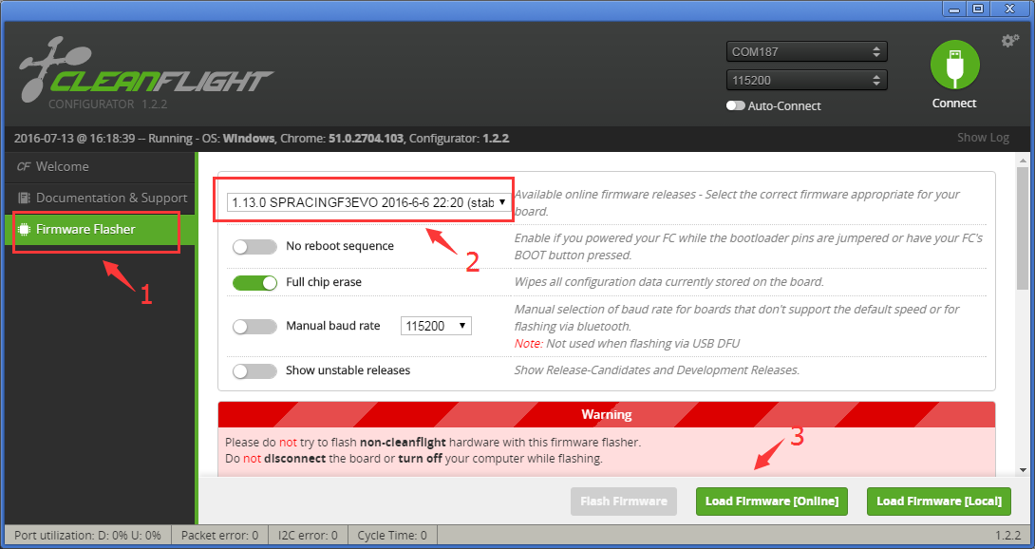

- Click “Flash Firmware” and wait the ST DFU DRIVER Automatic installation. It’s successfully installed when you see the DFU port on the Up right corner.
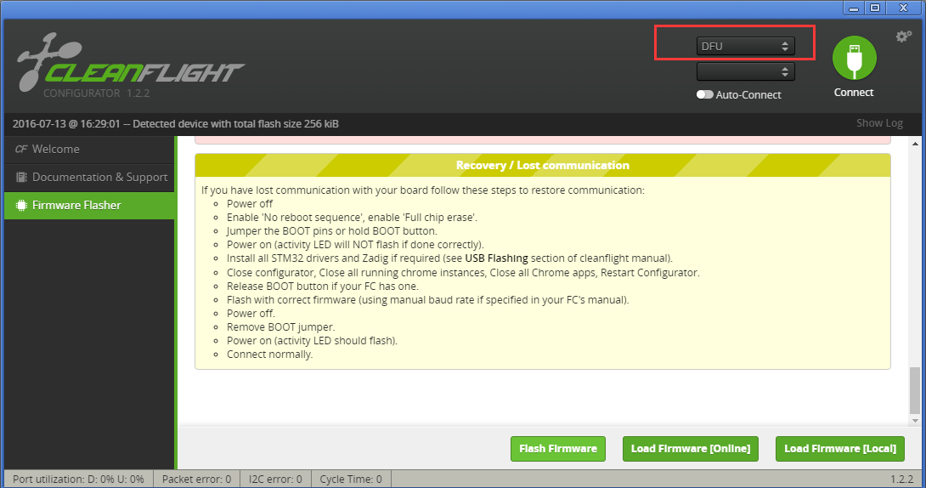
- Download and launch Zadig
- From Zadig, a.) Select Options, b.) Tick List All Devices
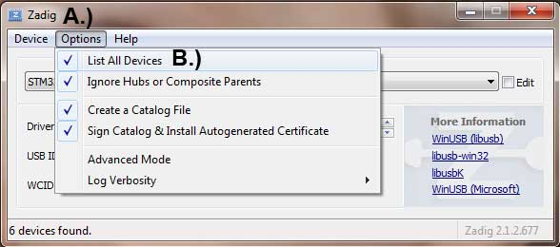
- a.) Select STM32 Bootloader from the dropdown, b.) Choose WinUSB as the replacement, c.) Click Replace Driver. Some times the Replace progress will be slow or no response, you can close it and do it again, you will find the dropdown is no STTUB30 but WinUSB, just click replace driver from WinUSB to WinUSB .
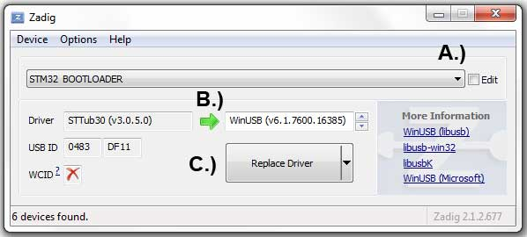

* Credits for the Zadig option – Cleanflight Docs

Flash Firmware
Go back to Cleanflight configurator and Click Flash Firmware again after the Driver replace completed, and you will see the firmware flashed successfully!

Warnings!
This Tiny F3 EVO_Brush flight controller is only use for BRUSH MOTOR, Not compatible for BRUSHLESS MOTOR

